Project requirements:

* 6.5 MVA, Single Phase transformer
* Operating Frequency: 500 Hz
* Input Voltage: 3 kV
* Output Voltage: 300kV
* Operating Temperature 110 °C

**Step 1 Selecting Core for 500hz application**

From JFE steel company website

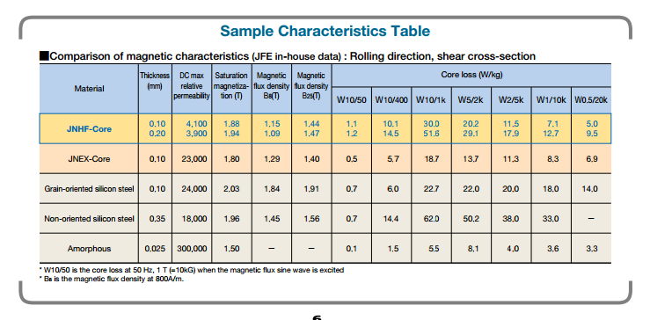

Lets assume operating Tesla vs loss stays linear until the saturation point .

There is no 500hz data readily available, so we need to curve fit the available data and determine and approximate loss value

Matlab code

x=[50,400,1000] %JNHF Core 0.1 mm at 1 Tesla

y=[1.1 , 10.1 , 30]

a=polyfit (x,y,2)

y=polyval(a,500)

x=[50,400,1000] %JNHF Core 0.2 mm at 1 Tesla

y=[1.2 , 14.5 , 51.6]

a=polyfit (x,y,2)

y=polyval(a,500)

x=[50,400,1000] %JNEX Core 0.1mm at 1 Tesla

y=[0.5 , 5.7 , 18.7]

a=polyfit (x,y,2)

y=polyval(a,500)

At 1 Tesla operating point

JNHF core 0.1 mm loss = 13.02 W/kg

JNHF core 0.2 mm loss =19.43 W/kg

JNEX core 0.1 mm loss = 7.5 W/kg

*stacking factor at 0,9 for 0.1 mm*

*stacking factor 0.92 for 0.2 mm*

**Step 1 Selecting Number of turns and operating tesla**

Our ratio is 1/100 ;

Lets select N1:10

N2:1000

Primary current is 6.5m/3k =2167 A

We are operating at 500hz , to have almost 100 percent skin depth our maximum cable diameter can be 5.8 mm which is about awg#3